PROJECT: CUSTOMER CHURN PREDICTION
Student Name |  | Role
Poorni Dasanayake |  | Project Manager
Milan |  | Data Analyst – Predictive Modelling
Virajkumar Shihora |  | Data Analyst – Clustering Analysis
Tanjia |  | Business Analyst
Nishil |  | Data Engineer – Preprocessing & Feature Engineering
Stage 2 Deliverable Optimal Number of Clusters Documentation

Optimal Number of Clusters Documentation

Introduction
The process of clustering analysis presupposes a huge parameter to guess the number of clusters as directly as possible, since it determines the quality and the value of the interpretation of the result. In this project, it was tested on different cluster platforms to determine the most suitable number of clusters with the aim of establishing which cluster configuration would best encapsulate the underlying infrastructure of the data.

Methodology
The methods that were used to assess the optimal number of clusters were the Silhouette Score Analysis and the Elbow Method. The methods provide complementary information regarding the performance clustering.
The Elbow Method values of the within-cluster sum of squares (inertia) with respect to different values of the clusters. The higher the number of clusters, the less the inertia. However, there comes a time when the gradient diminishes at a much slower rate, forming an elbow in the curve. This aspect demonstrates that there is the right amount of clusters to which there is no meaningful contribution to the model by adding extra clusters (Koli, 2023).
The Silhouette Score Analysis is employed to show the extent to which a certain data point is a part of a certain cluster in relation to other clusters. They range between -1 and 1, in which a higher value indicates more definite clusters. As has been noticed, the most appropriate number of clusters is normally associated with the most appropriate mean of the silhouette score.

Application in the Project.
This project clustered a number of values in the cluster. The values were computed to get the inertia and silhouette scores. These results have subsequently been plotted via a line plot in order to ease the process of selecting the most appropriate number of clusters.
The analysis determined the best number of clusters based on the elbow point of the inertia graph and the maximum score of the silhouette. This combined approach will lead to a compromise decision that will consider cluster compactness and separation (Sankalana, 2023).

Results and Interpretation
The obtained results of the conducted evaluations indicate that the count of clusters chosen provides a profound analysis of data. The number of clusters selected offers the best balance to decrease intra-cluster variance and enhance inter-cluster distance. This is translated into understandable and discernible customer groups, which are essential in inferences of actionable insights.

Visual Evidence
The visualisations will help in selecting the optimum number of clusters because it is easy to determine the point of diminishing returns (elbow) and the maximum performance of the clustering process (silhouette score).
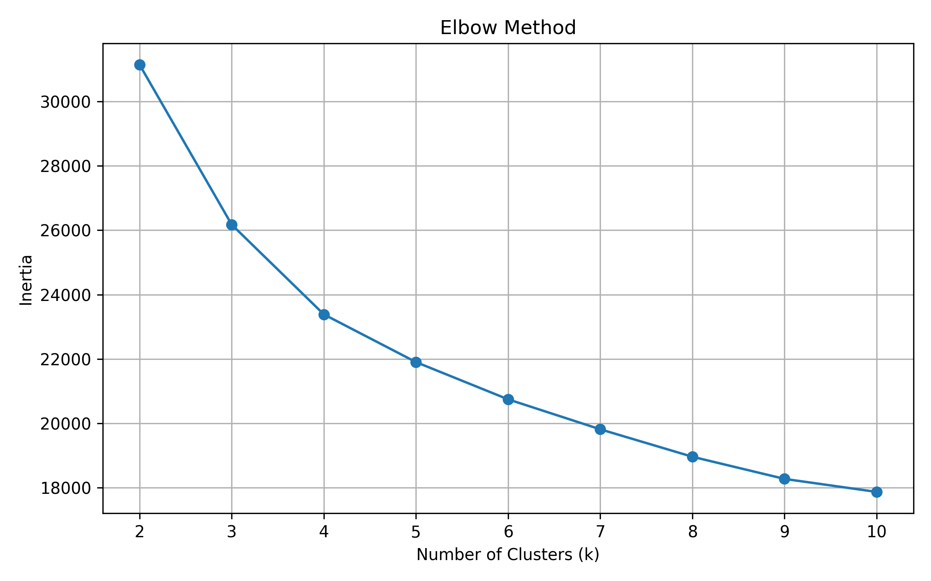
Figure 1 Optimal Number of cluster Visualization Using Elbow method
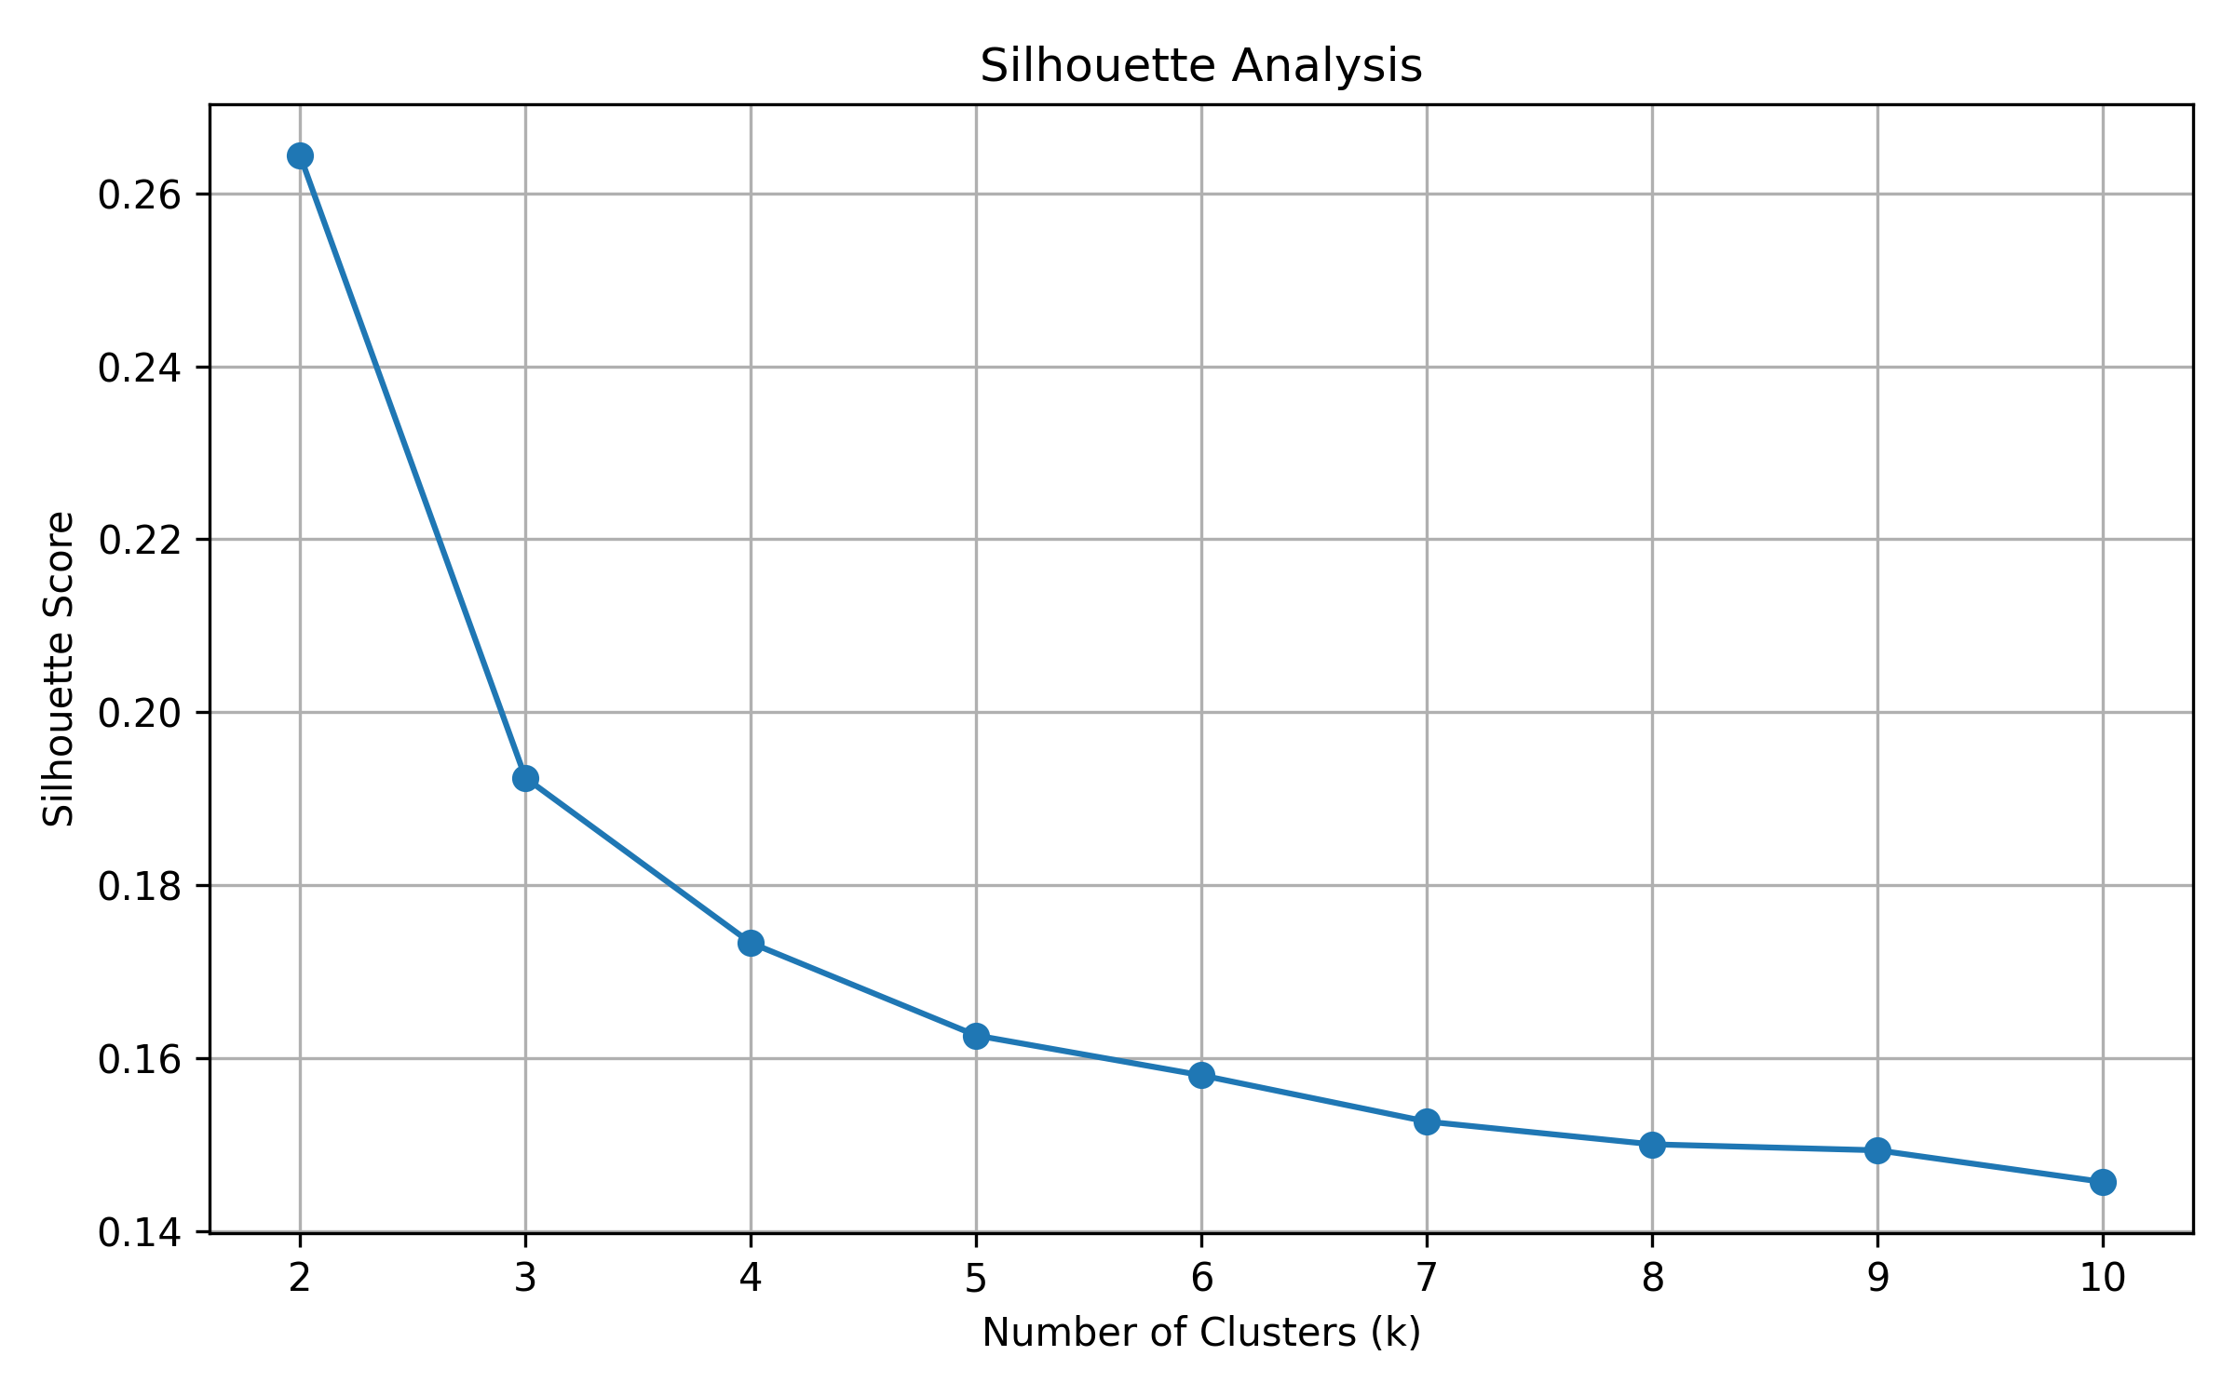
Figure 2 Silhouette Analysis Line plot

References
Koli, S. (2023). How to Evaluate the Performance of Clustering Algorithms Using Silhouette Coefficient. [online] Medium. Available at: https://medium.com/@MrBam44/how-to-evaluate-the-performance-of-clustering-algorithms-3ba29cad8c03.
Sankalana, N. (2023). K-means Clustering: Choosing Optimal K, Process, and Evaluation Methods. [online] Medium. Available at: https://medium.com/@nirmalsankalana/k-means-clustering-choosing-optimal-k-process-and-evaluation-methods-2c69377a7ee4.

